Sales Data Analysis Using SQL

KPI’S
1.Total Revenue
select sum(revenue) as Total_Revenue
from sales_data;
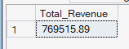

2.Total Orders
select count(distinct[order_id]) as Total_Orders
from Sales_data;
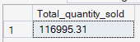

3.Average Order value(AOV)
select sum(revenue) / count(distinct[order_id]) as Average_order_value
from Sales_data;
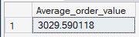

4.Monthly revenue (nov-dec 2022)
select sales_year,month_name,SUM(revenue) AS monthly_revenue
from sales_data
group by sales_year,Sales_month, month_name
order by Sales_month;
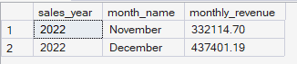

5.Best sales day
select top 1 order_date, sum(revenue) as daily_revenue
from Sales_data
group by order_date
order by daily_revenue desc;
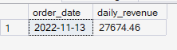

Business Requirement questions
1. Which product generates the highest revenue?
select [product], sum(revenue) as Total_revenue
from Sales_data
group by Product
order by total_revenue desc;
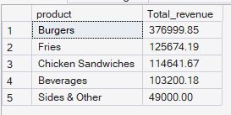

2. Which product performs best each day?

with DailyProductSales AS (
select Order_date,Product,SUM(revenue) AS daily_revenue,
ROW_NUMBER() OVER (
PARTITION BY [Order_date]
ORDER BY SUM(revenue) DESC
) as rn
from sales_data
group by Order_date, Product
)
select Order_date,Product,daily_revenue
from DailyProductSales
where rn = 1;
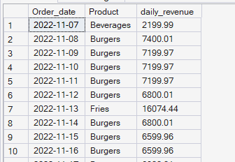

3. Which day had the highest revenue?

select top 1 Order_date, sum(revenue) as daily_revenue
from Sales_data
group by order_date
order by daily_revenue desc;
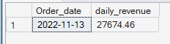

4. Is there month-over-month revenue growth?

with monthlyRevenue as(
select sales_year,sales_month, sum(revenue) as monthly_revenue
from Sales_data
group by sales_month, sales_year
)

select sales_year, sales_month, monthly_revenue, monthly_revenue
- lag(monthly_revenue) over (order by sales_month, sales_year) as growth_amount
from monthlyrevenue;
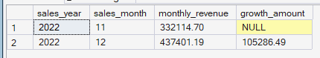

5. What percentage of total revenue does each product contribute?
select product, sum(revenue) as product_revenue,
round( sum(revenue) *100 / (select sum(revenue) from Sales_data),2 ) as reveune_percentage
from sales_data
group by product
order by product_revenue desc;
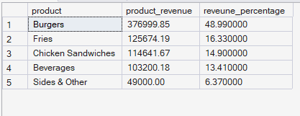

6. Which cities generate the most revenue?
select city,sum(revenue) as city_revenue
from Sales_data
group by city
order by city_revenue desc;
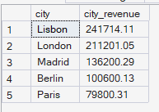

7. Top 3 cities by revenue
select city,total_revenue,city_rank
from(
select city,sum(revenue) as total_revenue,
DENSE_RANK() OVER (ORDER BY SUM(revenue) DESC) AS city_rank
from sales_data
group by City
) t
where city_rank <= 3;
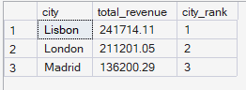

8. How does revenue accumulate over time?
select order_date, sum(revenue) as daily_revenue,
sum(sum(revenue)) over( order by order_date) as running_total
from Sales_data
group by order_date
order by order_date;
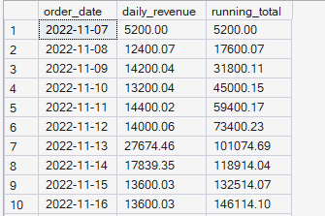

9. Which managers contribute the most revenue?

select manager, sum(revenue) as manager_revenue
from Sales_data
group by manager
order by manager_revenue desc;
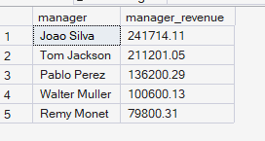

10. Which months performed above average?
with monthlyrevenue as (
select sales_year, sales_month,month_name, sum(revenue) as monthly_revenue
from Sales_data
group by sales_year, sales_month,month_name
)

select * from monthlyrevenue
where monthly_revenue > (SELECT AVG(monthly_revenue) FROM MonthlyRevenue);
